**Week 8:**

Create an application to demonstrate Gesture Detector.

**main.dart**

import 'package:flutter/material.dart';

import 'package:gesture2/home.dart';

void main()

{

runApp(MyApp());

}

class MyApp extends StatelessWidget

{

// This widget is the root of your application.

@override

Widget build(BuildContext context)

{

return MaterialApp(

debugShowCheckedModeBanner: false,

title: 'Gesture Detector',

home: GestureDetectorScreen(),

// home: MyHomePage(),

);

}

}

**home.dart**

import 'package:flutter/cupertino.dart';

import 'package:flutter/material.dart';

class GestureDetectorScreen extends StatefulWidget

{

@override

_GestureDetectorScreenState createState() => _GestureDetectorScreenState();

}

class _GestureDetectorScreenState extends State<GestureDetectorScreen>

{

Color color = Colors.teal;

Text text = Text("Hello! it's Teal Color",

style: TextStyle(

fontSize: 18,

fontWeight: FontWeight.bold

),);

@override

Widget build(BuildContext context)

{

return Scaffold(

appBar: AppBar(

backgroundColor: Colors.deepPurpleAccent,

centerTitle: true,

title: Text('Gesture Detector Demo'),

),

body: Center(

child: GestureDetector(

**onTap: ()**

{

setState(() {

color = Colors.amber;

text = Text("Hello! it's Amber Color",

style: TextStyle(

fontSize: 18,

fontWeight: FontWeight.bold

),);

});

},

**onDoubleTap: ()**

{

setState(() {

color = Colors.blueAccent;

text = Text("Hello! it's Blue Color",

style: TextStyle(

fontSize: 18,

fontWeight: FontWeight.bold

),);

});

},

**onLongPress: ()**

{

setState(() {

color = Colors.deepOrangeAccent;

text = Text("Hello! it's Orange Color",

style: TextStyle(

fontSize: 18,

fontWeight: FontWeight.bold

),);

});

},

child: Container(

decoration: BoxDecoration(

color: color,

borderRadius: BorderRadius.circular(20)

),

width: 250,

height: 200,

child: Center(

child: text,

)),

),

),

);

}

}

**OUTPUT:**

**Application Loading**

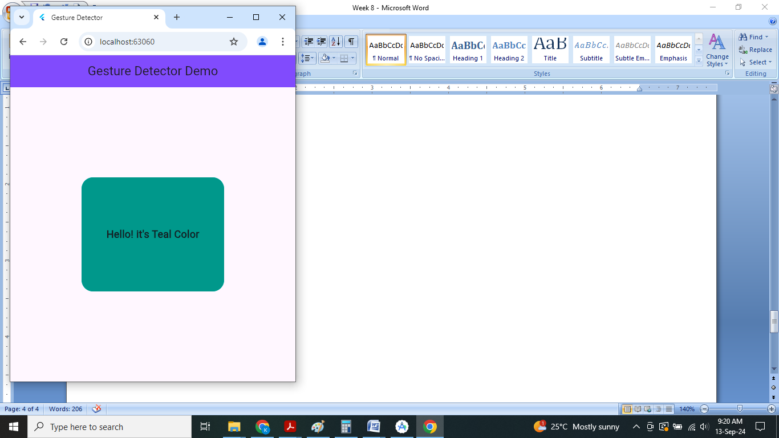

**When apply Single Click**

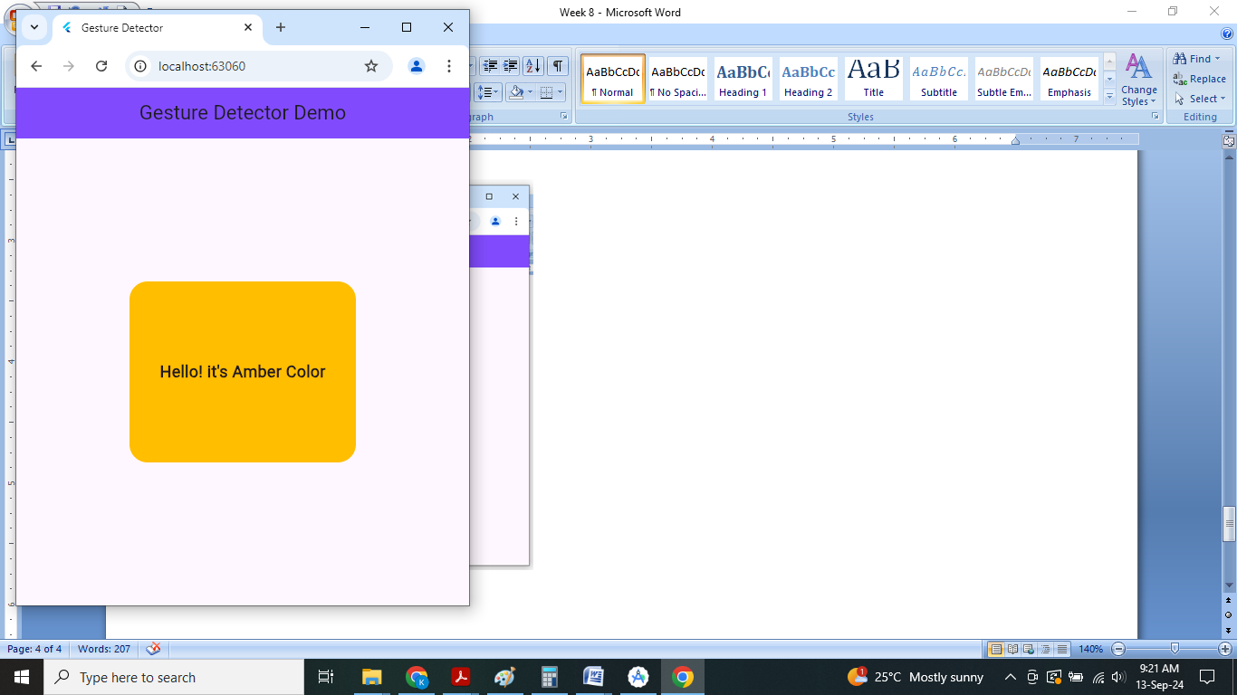

**When apply Double Click**

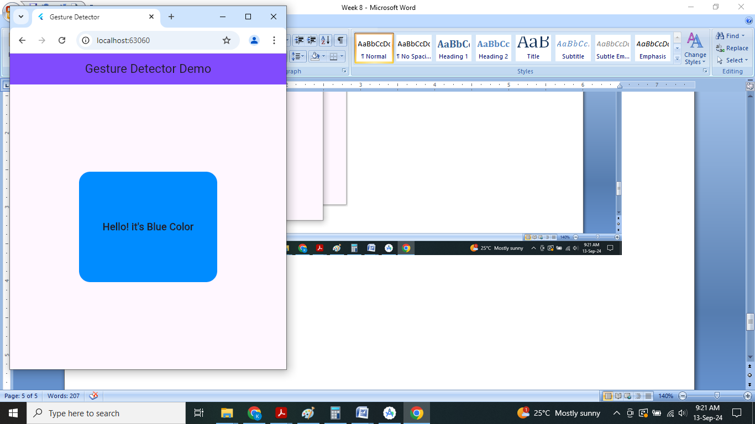

**When apply long press**

